# **Doing Something**

**Zoe's avatar**

[Zoe](https://substack.com/@zoeffc)

Oct 04, 2024

Share

Hey guys,

I have found it really hard to focus this week. Last Friday, a massive storm devastated the western part of North Carolina. While I was not personally impacted, so many families lost everything. It is hard to even comprehend.

Talking about productivity and work-life-balance feels… not right to me at the moment. Instead, I want to share some thoughts on disaster giving, links to charitable organizations, and some memes that made me smile, and I hope might make you smile as well.

To those of you who are feeling the impact of this storm more directly, I am so sorry. Please take care of yourself. Your community will benefit from you being a solid foundation for them to rebuild with.

First some housekeeping:

📫 If a friend forwarded you this newsletter (then you have some really cool friends), and you may want to consider joining us here for regular updates.

[Subscribe](https://femme-futures.beehiiv.com/subscribe)

🧲 Got some thoughts you want to share? Join us on Discord to chat all things newsletter and corporate life.

[Discord](https://discord.gg/N84WxemQ?utm_source=femme-futures.beehiiv.com&utm_medium=referral&utm_campaign=doing-something)

You can find all archived newsletters at the online site, if you ever want to go back or if you just feel like perusing.

[Check out the website](https://femme-futures.beehiiv.com/)

For those who don’t know, I am a professional fundraiser by day. I have been in this industry for a few years, working with grassroots nonprofits, international nonprofits, and large scale philanthropic organizations. All that is to say that I have some thoughts on how to effectively give your money.

1. **If you know people impacted—ask them what they need.** There are community forums, and mutual aid groups focused on immediate and local support. They are directly addressing the needs of the impacted communities. That is the most effective way to help folks get back on their feet.
2. **Cash is more versatile than toilet paper.** That sounds silly, but it is common knowledge in fundraising that money that is donated without limitations (“unrestricted funds”) are far more useful than that donated which can only serve a specific function (“restricted funds”). As a donor, you don’t know what each organization’s finances look like. They may have more money than they know what to do with for clean up efforts but not enough money to ensure that their volunteers have access to running water while they work. If you trust the organization, you should consider allowing them to make the call of how the influx of cash is used.
3. **If there is a cause that you are particularly passionate about, focus your efforts there.** Disasters like hurricane Helene have long-term impacts across the philanthropic sector. Just like so many households, local Planned Parenthoods and women’s heath clinics also lost power and likely sustained water damage. If reproductive justice is what fires you up, focus there. I have a climate background, so organizations that focus on implementing effective climate legislation are really important to me. In the aftermath of Helene, it is not hard to see how necessary it is to address the climate change issue, especially as it disproportionately impacts low-income communities, like those in Appalachia.
4. **Do your homework.** This is the hard part, but not all nonprofit organization are created equal. Your money will go further with some than with others. If you aren’t sure which organizations to trust, find one with a recognizable name, or one that an impacted community member has specifically recommended. (IF YOU ARE ALSO A FUNDRAISER LIKE ME — look at 990s, look at c-suite compensation, etc.)

I reached out to a friend who’s family was severely impacted by the hurricane to see how I could best support the communities of Western NC. I wanted to share her recommendations here:

* Raleigh United Mutual Aid Hub ([*RUMAH*](https://www.raleighmutualaid.info/?utm_source=femme-futures.beehiiv.com&utm_medium=referral&utm_campaign=doing-something)) is good for local (to me) supply drives.
* [*BeLoved Asheville*](https://belovedasheville.com/?utm_source=femme-futures.beehiiv.com&utm_medium=referral&utm_campaign=doing-something) is books on the ground in the area
* [*Hearts With Hands Swannanoa*](https://www.heartswithhands.org/?utm_source=femme-futures.beehiiv.com&utm_medium=referral&utm_campaign=doing-something)

Other organizations to consider donating to:

* [*Habitat for Humanity Asheville*](https://www.ashevillehabitat.org/?utm_source=femme-futures.beehiiv.com&utm_medium=referral&utm_campaign=doing-something). Habitat for Humanity focuses on building homes for people who need access to them. They tend to be locally run which means that if you donate to Asheville, Knoxville, etc, your funds will be used in that particular location.
* [*Red Cross*](https://www.redcross.org/about-us/news-and-events/press-release/2024/red-cross-responds-to-hurricane-helene.html?utm_source=femme-futures.beehiiv.com&utm_medium=referral&utm_campaign=doing-something). Someone in my life is a Red Cross volunteer and she was saying that now, a little bit under a week post-disaster, their teams are converting from immediate disaster response to long-term disaster response which means that they have stopped the metaphorical bleeding and are now more able to efficiently deploy aid. A donation to them now could go a long way.

Last thoughts:

I am not religious, but moments like this remind me of the deep importance of religious communities to disaster response. Church leaders represent the frontline caretakers for many of the communities impacted. Not only do they support your spiritual wellbeing, which is critical in the aftermath of disaster, but they often act as an additional community organization where supplies can be donated, temporary shelters placed, and food distributed. If it is available to you, considering donating to a faith-based organization.

It sucks to feel useless in moments like this. It sucks to know that people are suffering and there is relatively little that you can do to alleviate that. I want to remind you that (1) anything that you are able to do can have an impact, and (2) there are really good and smart and capable people out there responding. Just like we have recovered from every past tragedy, we will recover from this one as well.

Sending love,

Zoe

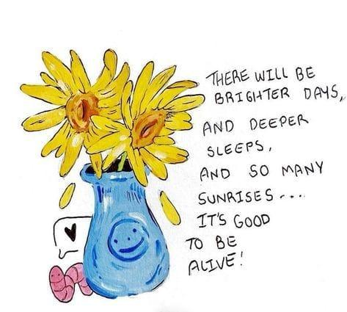

[](https://substackcdn.com/image/fetch/$s_!X-aU!,f_auto,q_auto:good,fl_progressive:steep/https%3A%2F%2Fsubstack-post-media.s3.amazonaws.com%2Fpublic%2Fimages%2Fd878a52e-b578-49e3-8790-bc212294f96a_473x425.jpeg)

[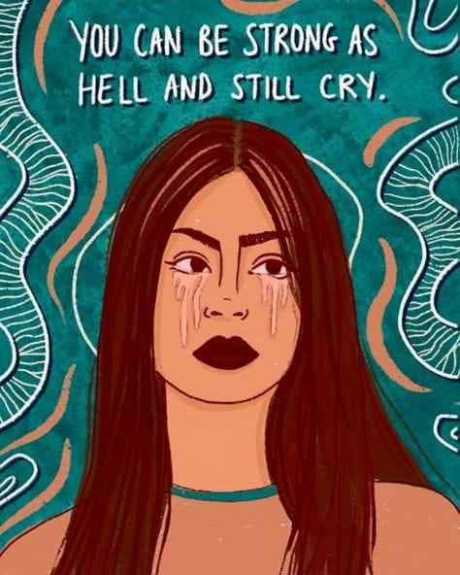](https://substackcdn.com/image/fetch/$s_!JI5Y!,f_auto,q_auto:good,fl_progressive:steep/https%3A%2F%2Fsubstack-post-media.s3.amazonaws.com%2Fpublic%2Fimages%2F6f15431f-5838-442a-bfcd-6d01259d29ea_473x574.jpeg)

[](https://substackcdn.com/image/fetch/$s_!8HAc!,f_auto,q_auto:good,fl_progressive:steep/https%3A%2F%2Fsubstack-post-media.s3.amazonaws.com%2Fpublic%2Fimages%2F7d049ed6-58ec-42c6-a914-cb406db642b4_474x592.jpeg)

**Femme Futures Cooperative Founding Principles**

💚 **Mission**: The mission of Femme Futures is to create a community space for young professionals who identify as over-achievers and activists to generate collective success by providing resources and platforms to thrive in challenging workplace environments.

💙 **Vision**: To contribute to a world where driven individuals are equipped with the tools, guidance, and connections to overcome systemic barriers, fully utilize their talents, and enact positive change in their organizations and communities.